**Chat Identity**

**Profile – EMPTY**

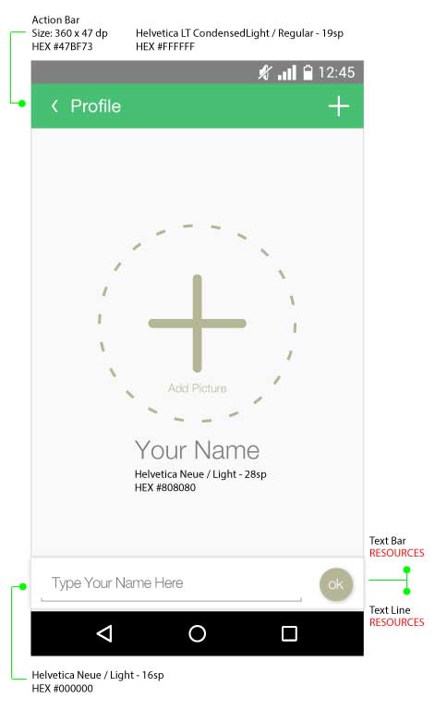

**Picture – CHOOSE OPTION**

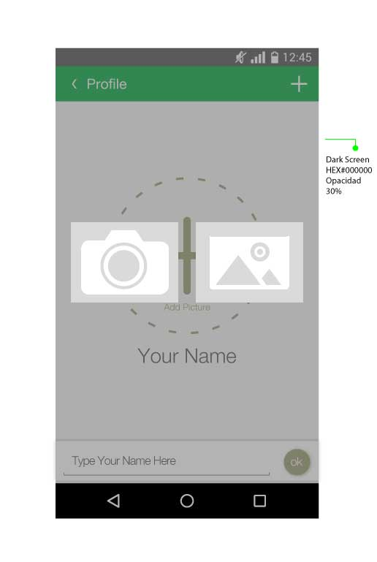

**Profile – FULL**

